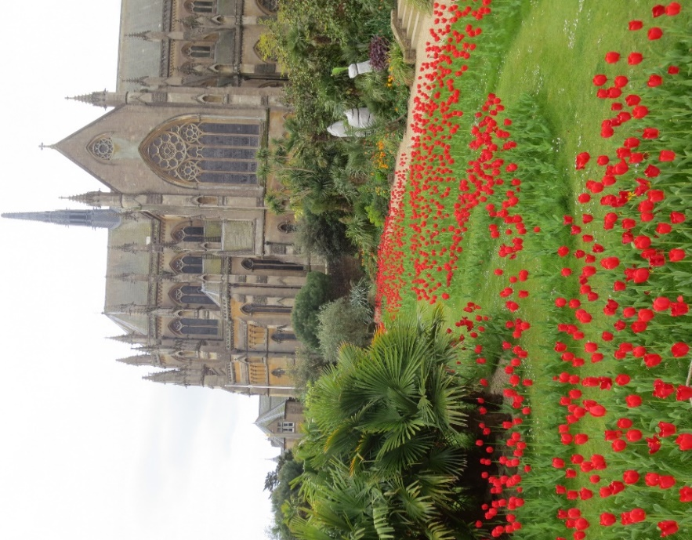
NEWSLETTER SUMMER EDITION - JUNE 2017
“Those April showers…….. arrived in May”. They certainly didn’t come in April this year as it was the driest for more than twenty years and the garden hoses and watering cans came out early. But April and May were sunny with much longer than average sunshine, after yet another mild winter, so spring flowers and blossom were the best in memory until an exceptionally hard frost overnight on 27th April knocked over most new growth. Some Roses were already blooming by then - and will be with us until December, hopefully, - but the year is rushing by with so little time to enjoy things at their seasonal best and to keep up with all those gardening jobs. Hey-Ho, that’s gardening for you.
Castle Tulips. I hope you didn’t miss seeing the quite amazing displays of tulips this Spring, just over the wall in the Castle gardens. Over two thousand visitors a day were recorded - including some from The Netherlands who know a thing or two about growing tulips. Congratulations are due to our President, Martin Duncan, Head Gardener at the Castle, and his team for creating such a wonderful spectacle. We are already looking forward to next year!
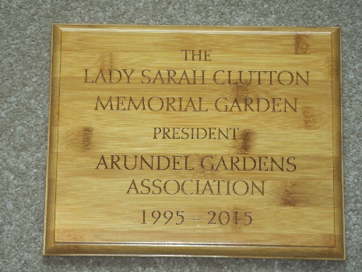
The Lady Sarah Clutton Memorial Garden. This plaque has been installed in the delightful small public garden in River Road in memory of the Association’s late President. The garden will continue to be tended by local residents, including members of the Association, and will remain freely available to the general public. The naming of this quiet oasis of calm is a fitting memorial to our much-loved President who loved her gardens.
Membership. Thanks are due to the thirty or so members who visited our stall at the April Farmers’ Market to pay their annual subs and collect their Membership Cards. We also welcomed several new members joining our ranks. Payments can still be made at the Depot in Park Place on Sunday mornings until the end of July or by sending them to our Membership Secretary, Monica Saunders at 16 Canada Road, BN18 9HY, but this will be the last Newsletter for non-payers. Already nearly one hundred of our three hundred members receive Newsletters by e-mail, and in colour. This saves on printing costs and reduces the work of our helpful volunteers. May we have your e-mail address, for Association Newsletters only?
Outing to Wisley. The coach is nearly full so if you are reading this before 14th June and would like a seat please contact Theresa urgently on 01903 882459. This promises to be a fabulous day out, seeing Wisley gardens in all their summer splendour. Wisley is one of four RHS gardens, arguably the best, and we are fortunate that it is just over an hour’s drive from Arundel. Cost £15 inclusive.
The next afternoon Outing is to St. Mary’s House Gardens in Bramber in early September. There are five acres of beautiful gardens including a “Secret Garden” with original Victorian fruit wall, pineapple pits, a superb rose garden and a landscaped water garden. A smaller, sixteen-seater coach is planned to keep costs down so places will be allocated on a first-come-first-served basis. £20 for coach and garden only. Early reservations should be made to Theresa.
NGS Garden to visit. The Grange, Hesworth Lane. Fittleworth. RH10 1EW 22-23 July 2 – 5. £4.50. Children free. Three acre, gently sloping garden down to River Rother. Themed beds, potager, herbaceous borders. Home made teas!
Plant Sale. Pulborough Village Hall. RH20 2BF. Sunday morning 12th .
Bosham Open Gardens. Sunday 11th June. 11-5. £7
“In my garden” – Pat Jackman updates us on her late Spring garden.
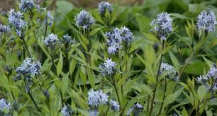
“The rain has refreshed the plants and made the soil workable again so it’s all systems go to get any new plants in the ground and, for me, the dahlias are a priority as they are bursting out of their pots! I have overwintered and grown on Dahlia ‘David Howard’, a decorative type with apricot flowers and dark foliage, ‘Downham Royal’ a purple pink pompon type and ‘Thomas Edison’ another decorative type with huge violet flowers that makes a real impact in the border. I usually add some bonemeal to the planting hole and, after watering them in, mulch each plant to preserve moisture. I always put three canes in a triangle to support the dahlias because they grow tall and heavy and can be damaged on windy, wet days. I have used the stems of dark red Cornus to stake the perennials and because they are pliable I can weave them together in a framework around the plants and they blend in well. I went to a plant fair this week and couldn’t resist buying (of course!) a new Sedum ‘Jose Aubergine’ with purplish sturdy stems, which don’t flop I am assured, that carry broad heads of reddish-pink flowers and at 45cm x 45cm it’s good for the front of the border. The other plant was new to me - Amsonia tabernaemontana var. ‘salicifolia’ - has star-like steely blue flowers in clusters on strong stems, it grows to 0.9m and flowers May to July. I saw it in the borders at Polesden Lacey and was attracted by the blue starry flowers – an unusual colour in May – and a few days later found it on a stall at the plant fair which rarely happens so I hope it is a good omen!”
Arundel’s Schoolchildren. Association members are now regularly working with children at our two local schools in their gardens and allotment. Theresa and George visit Arundel Church of England School each week during term time and Geoff and Bob are at St. Phillips. The children have an infectious enthusiasm and squeal with delight as they discover worms, woodlice, ants and other creatures while planting seasonal plants and dealing with often heavy weed growths. Tolerant parents or guardians don’t seem to mind when the children return home with muddy shoes and clothing, and sometimes soaking wet, eager to tell of their latest gardening adventures. The helpers have fun too! Hopefully, the children are also learning about growing things!
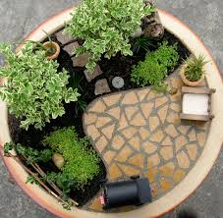
All Arundel children between the ages of 5 and 11 will be able to enter the Junior Section of this year’s Arundel Flower and Produce Show on August 12th at the Football Club. There are four classes, two for children aged 5 – 7 years and two for those aged 8 – 11 years. Children can enter their drawing or painting, entitled “My Lovely Garden”, and also by creating a miniature “My Garden” on a 12 inch plate.
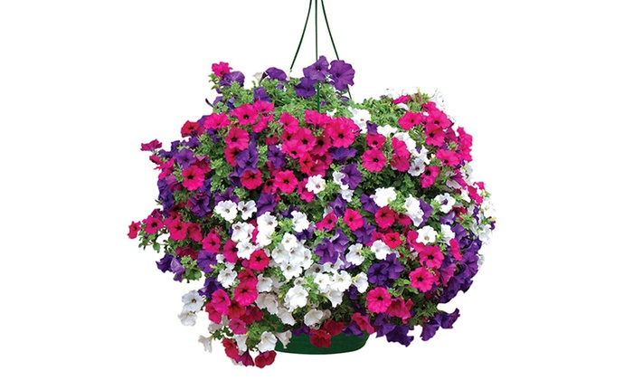
There will be lots of opportunities too for Arundel’s adult residents to enter the other 36 Show Classes, including vegetables, fruit and flowers, floral art, cookery and even compost making. Watch out for the Show Programme containing details available soon at several places throughout the town.
Arundel in Bloom. No, Arundel has not entered that competition again this year but I am confident it will not stop many residents and businesses from ensuring Arundel looks “blooming lovely” again later this summer. Start your walk at the War Memorial where the Town Council will have planted the small beds with attractive annuals, then stroll past the White Swan pub where the hanging baskets are always spectacular and seem to improve well into autumn. Many cottages along River Road have inspirational window boxes to admire before you come to the delightful public garden mentioned earlier. Having rested, walk back along Tarrant Street, passing attractive front gardens, then climb Bakers Arms Hill where more small gardens delight the eye. Turn right along Maltravers Street to admire yet more hanging baskets – they’re having a comeback this year, reportedly - and front-door potted plants, before reaching the High Street again to marvel at the huge hanging creations adorning the Chinese Restaurant. This short walk around the town centre provides but a sample of the gardening talent to be found throughout Arundel and I am left believing other communities have a better chance of success in that annual Blooming contest in Arundel’s absence.
Allotment Reports. “What a strange start to the growing year”, wrote Rita Godfrey, just before showers arrived. “Although everything is taking off we are now short of water - in spring - in England! It just goes to show you can never predict how nature will help or hinder us in our allotments. One good outcome of the lack of water is, of course, the lack of slugs and snails which means that so far we haven't lost our young plants to these greedy creatures and the dry weather has meant that there have been more days when we have been able to be on the plot so it actually looks a bit tidier than normal. A snap frost in April took the tops out of some of my tomatoes in the greenhouse but apart from that we got off lightly and the asparagus has been great. So now the seeds are in and the young plants are out and we are back to weeding and hoeing and looking forward to trying the Celtuce and Cucamelons, the new varieties I have tried this year. Happy summer in the garden to you all.”
Now a similar tale from Mike de Lara but with some good news too. “I cannot write without commenting on the lack of rain. 2 days in 8 weeks is just not enough. The experts tell us that climate change will have the effect of this sort of phenomena becoming more pronounced. It certainly taxes our judgment as gardeners. My policy of going early to get the roots established has certainly paid off, but as I write I had the hose going for 2 hours last night. There comes a point where we all need a helping hand.
In the last issue I promised you results of using old seed. As a generalisation 1st year 95% germination, 2nd year 75%, 3rd year 25%. There are exception: for parsnips always use fresh seed but basil, cape gooseberry and watercress don't seem to care how old the seed is. Happy Gardening!”
Gardening is Good for You! Public Health experts have concluded that gardening is good for you! Surely, that’s stating the blindingly obvious and we gardeners have always known that a few hours light work in the garden, or on the allotment, on a regular basis, has benefits to one’s physical well-being. But they go one step further: not only does gardening beat the gym for keeping the body in shape but mental health also benefits to a much greater degree than previously thought.
Even folk who are no-longer active gardeners can continue to benefit by visiting gardens, attending illustrated talks on gardens, reading the gardening literature and maintaining a “healthy” interest in all things gardening. I’d say that’s a good commendation for Association membership, wouldn’t you?
Community Orchard Report, from Nell Paton. “The Orchard was visited by 60 children from Arundel’s primary schools at the beginning of May. They sowed a ‘wildflower meadow’, mulched the fruit trees and made bird feeders from milk and juice cartons to take home. Do keep an eye on Arundel Community Orchard Facebook for news of how the flowers are doing and when it’s a good time to go down and see them in bloom.
The children had a lot of fun, and we very much enjoyed assisting them with their projects and seeing their enthusiasm. We are now working on arrangements for The Arundel Community Apple Day, which will be on Sunday, 15th October, from 11am to 3pm. Make a note in your diaries, and when the time comes, gather up your apples to be pressed, and come along to see the stalls, go on an Orchard Tour, listen to some music and then take some apple juice home with you.”
Depot - EXTENDED OPENING THIS SUMMER. Your Committee has decided to extend Depot opening to the end of July this year so there will be four extra Sunday mornings when members can purchase many gardening products at preferential prices. The Depot will now close on July 30th. A new supply of quality bamboo canes is among popular items as gardeners build their bean rows or provide support for dahlias, sweet peas and other border favourites.
Talks Programme. On Thursday 5th October Peter Liverman will entertain us with his talk on growing Alpines. Fellow-member Peter is Secretary to the West Sussex Group of the Alpine Society. Arundel Museum 7.15 for 7.30p.m.
Chelsea Flower Show 2017. A Brexit-affected Chelsea Flower Show has come and gone. There were far less Grand Gardens than usual as sponsors declined investment but, on the TV, the Show looked as spectacular as ever. Does it continue to inspire us humble gardeners, with its display of perfection, or reaffirm that perfection is out of reach for those without a fortune? Discuss!
Have a blooming lovely summer. Bob Tanner, Chairman, AGA bobtanner1809@gmail.com http://arundelgardensassociation.co.uk

